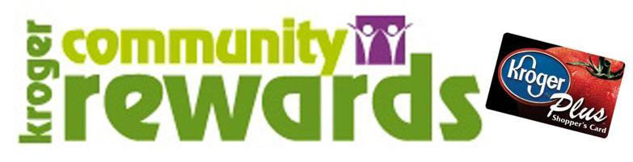

Would you like to DONATE to the school with NO HASSLE?

Kroger, Corp offers us a wonderful opportunity to earn extra money for our school every year. The Kroger Community Rewards Program pays us back for money we spend at Kroger. We currently have 110 families, of the 500 families currently enrolled in Point Harmony, participating in this program.

Since we began using Kroger Community Rewards (September 2015) the school has received approximately $4,000 per year! This money has been used to pay for the Tech Lab teachers, and other various equipment for the school… ink, paper, printing of the calendar/handbook, just to name a few. We’ve received this amount with only 100 of our staff and families contributing. Can you imagine how well we would do if ALL 500 families, staff AND their families joined in? Anyone in any state that shops at Kroger, can participate in this program!

It’s easy to do and it takes NOTHING away from your Kroger Points.

Go to www.Kroger.com, Savings, Kroger Community Rewards, I’m a customer, that’s it! As always, Point Harmony Staff and Students appreciate the support of our community!
